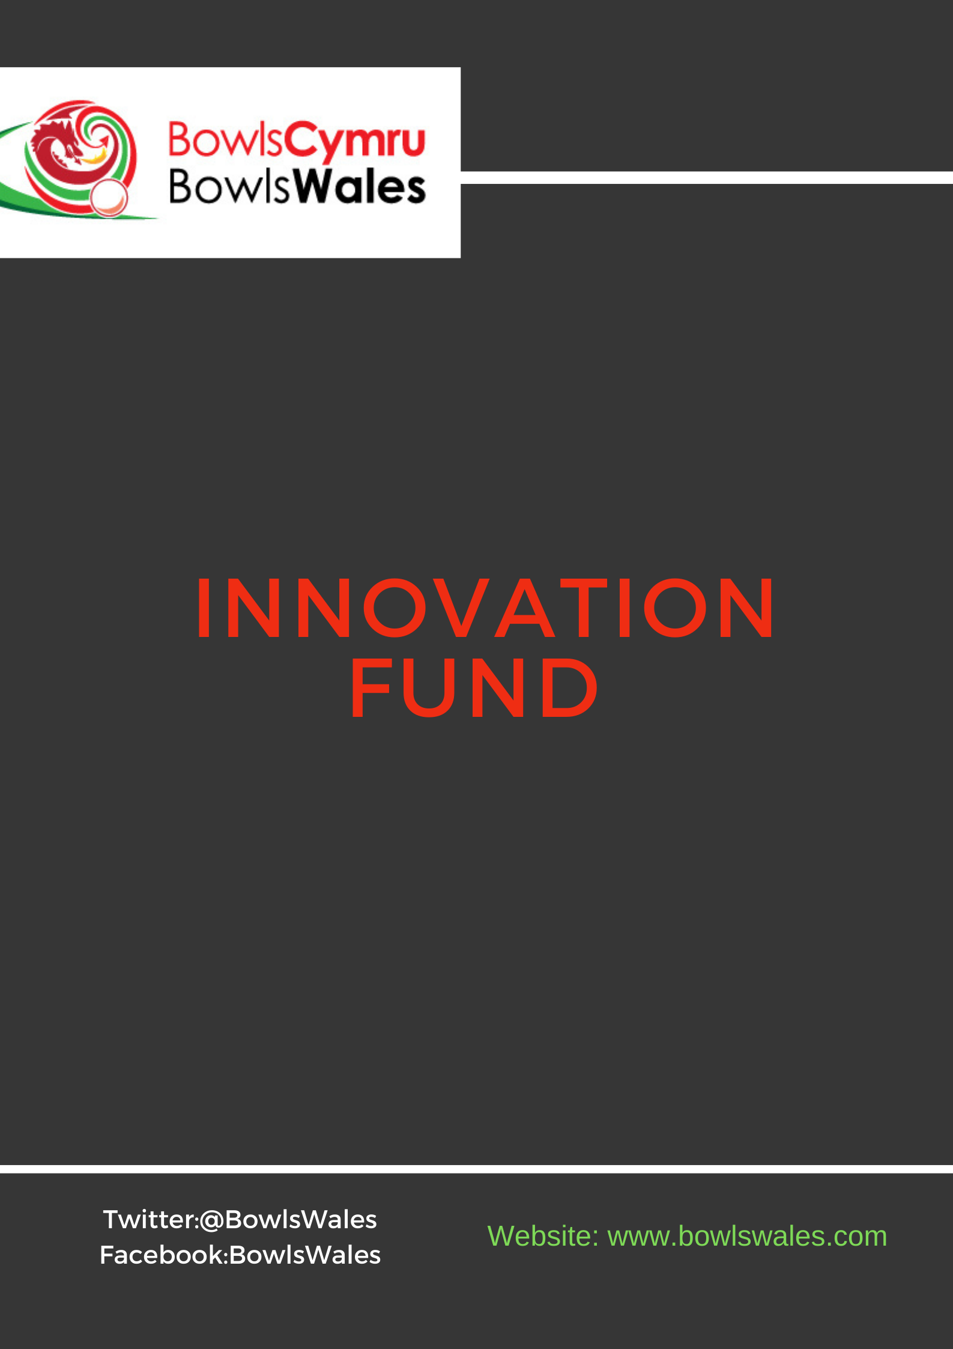

Application Form Content
Important points to note
Before starting to complete the application, we ask that you have thoroughly read and understood the Innovation Fund support & guidance document and can adhere to the Criteria and Conditions. The BowlsWales team are here to guide you in meeting any outstanding eligibility criteria.
If you have any questions relating to any elements of this fund, please contact the development officer on Claire.joll@bowlswales.com
Completing the application
Please read the questions carefully and ensure your club/facility can meet the criteria, if not this will make your application void. Some questions are mandatory, and some are for information only. Some questions have a specific word count. Please provide clear, concise answers and list information as appropriate, no additional documentation outside of the application form will be accepted unless specifically requested.
Guidance notes are provided to support you in completing the application.
Clubs can apply online via the Innovation Fund Application form. Clubs can find the application form on the BowlsWales website which can be submitted via email to enquiries@bowlswales.com

APPLICATION FORM
Data Protection & Privacy Notice
BowlsWales are committed to comply with all relevant data protection legislation, and to ensuring that all personal information provided to us is handled properly. We will use the information you give us on this application and any supporting documents to:
- Assess applications
- Monitor funding/grants
- Evaluate the impact of funding
- Report to our stakeholders
We may also give copies of the information provided to other organisations such as:
- Our accountants, auditors or other external advisors or evaluators
- Any other organisations involved in delivering the project
- Other organisations for the prevention and detection of fraud, bribery, or other offences
⇨ Please tick to confirm that you understand what we may do with the information contained in this application and supporting documents and that you consent to it.

Application Form *Mandatory Fields
- Contact Details
Lead Contact*:
Title

First Name

Surname

Role / Position

Email address

Daytime telephone number

Secondary Contact*:
Title

First Name

Surname

Role / Position

Email address

Daytime telephone number

2. Club/Facility Details
Name of Bowls Club or Facility*:
Address line 1

Address line 2

Address line 3

Town County

Postcode

Main email address

Telephone number

2.2 Is your club affiliated to a National Governing Body? Please provide detail of the NGB below. If not affiliated, please specify.

2.3 Is your club incorporated?* Yes / No

2.4 What is your current legal status?* (Unincorporated Association, Company Limited by Guarantee, Company Limited by Shares, Industrial and Provident Society, Community Interest Company, Charitable Incorporated Organisation, Sole Trader, Public Limited Company, Limited Partnership, Limited Liability Partnership, Charity, Co-operative Society, Co-operative Benefit Society, Other, Unsure)

2.4 Are you a Community Amateur Sports Club (CASC)?* Yes/No

2.5 Does the club/facility occupy land freehold or leasehold, of by any other arrangement?* (Freehold, Leasehold, Other (if other please give details)

2.6 Do you have strategic/business plan?* Yes / No / under development

2.7 How many people sit on your Board/Management Committee or ‘other group’ who are responsible for the running of the club or facility? *
Breakdown of Staff
Volunteers

3. Membership
3.1 What is your total membership (please include all types of membership)?*

3.2 How many current members do you have in the following categories?*
 | Number of Bowlers | Number of bowlers with a disability or impairment  (if known)
Adult males
Adult females
Junior boys
Junior girls

4.Commitments
The BowlsWales team can help you will all areas below if you require support and can also cross reference with past club work.
4.1 Do you have an Equality & Diversity Policy in place or are committed to having one in place by June 2021?* Yes / No / Already have a policy in place
4.2 Do you have an Safeguarding Policy in place or are committed to having one in place by June 2021?* Yes / No / Already have a policy in place / require further support(please contact Claire.joll@bowlswales.com
4.3 Commitment to reviewing and implementing good governance practice (where applicable) Yes/No
4.4 Adhered to legislation and government guidance relating to COVID-19. Yes/No
4.5 Will provide 3 quotations for capital projects (where possible) with the application Yes/No

5. Funding Requirement, Impact & Innovation
5.1 Funded Area/s or Project Name/s:*

5.2 Total Funding request*: £ _________

5.3 Please itemise what this funding will be used for?*

5.4 In up to 250 words, please tell us how your ideas are intended to further develop and support Bowls in Wales*

5.5 In up to 250 words, please tell us what impact this funding will have on your club or facility*

5.6 In up to 250 words, please explain how you will ensure this is sustainable and how you intend to further manage recovery. In addition, what else are you doing to support future sustainability at your club/facility?*

5.7 Project Timeframes* Start month: _____End month: _____

6. Financial Need
6.1 Income Breakdown (£): (if not applicable enter n/a)
Last Financial Year (£) Budgeted for 2020 (£)
Projected Impact2020 Post COVID:
Membership Revenue
Bar/ Catering
Other revenue
Total
Income Breakdown
Additional Information

6.2 Expenditure Breakdown (£): (if not applicable enter n/a)
Last Financial Year (£) Budgeted for 2020 (£) Projected Impact
2020 Post COVID
Green Overheads
Club house overheads
Bar/ Catering
Other revenue
Total
Income Breakdown
Additional Information

6.3 In up to 250 words, is there any other information that you would like to share with BowlsWales to support your application?

7 Review & Sign off
Thank you for providing the information requested for this fund. Applicants will receive notification as to whether they have been successful via email the week commencing 7th June 2021.
Club Declaration
1. The person completing the application has been authorised by the Club Management Committee/Council/Board to submit the application form online on their behalf.
2. By submitting the application, the Club Management Committee/Council/Board declare that the information provided in relation to your club is true and complete to the best of their knowledge.
3. By submitting the application, the Club Management Committee/Council/Board are aware that applications over £1k require a 10% contribution from the club towards the application. (Please refer to the support and guidance document).
⇨ Please tick to confirm that you have read all supporting information relating to this fund and agree to
The Innovation Funding Criteria & Conditions
Lead Applicant Sign __________________________
Date ___________________

